Test Case ID | Test Description | Prerequisites | Test Steps | Test Data | Expected Result | Actual Result | Status | Created By | Date of Creation | Executed By | Date of Execution | Screenshot
TC001 | Log in | User registered | Open login page → Enter credentials → Click login | Username/password | Login successful OR error for invalid credentials | If correct credentials entered, user dashboard opens | Pass | Zubayer | 12-Mar-2026 | Zubayer | 12-Mar-2026 | 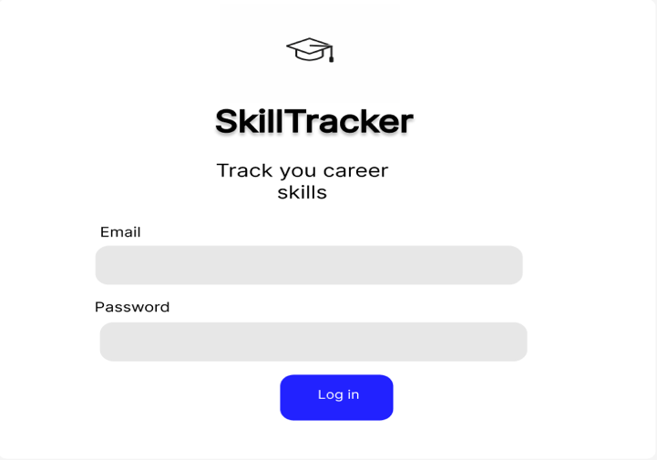
TC002 | View dashboard | Student logged in | Login → Navigate to dashboard | N/A | Dashboard displayed | Dashboard loads successfully | Pass | Zubayer | 12-Mar-2026 | Zubayer | 12-Mar-2026 | 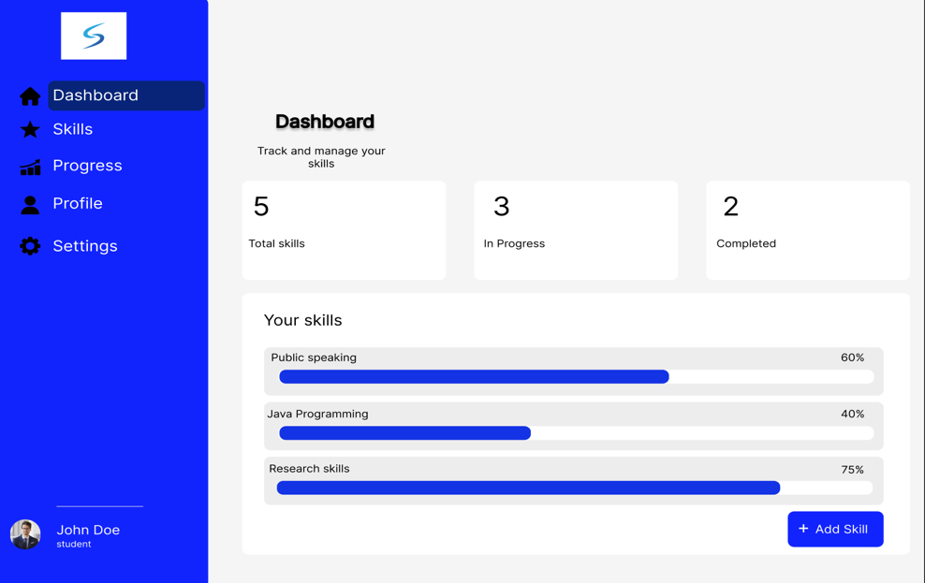
TC003 | Add new skill | Student logged in | Manage Skills → Add new skill → Save | Skill name | Skill added successfully | Skill appears in skill list | Pass | Zubayer | 12-Mar-2026 | Zubayer | 12-Mar-2026 | 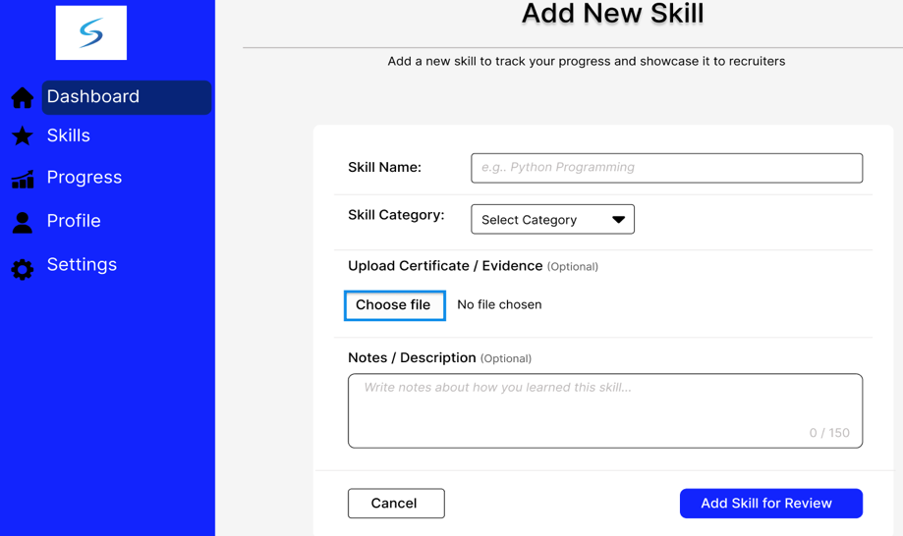
TC004 | Submit skill for review | Skill added | Select skill → Submit for review | Skill | Skill sent for review | System confirms submission | Pass | Zubayer | 12-Mar-2026 | Zubayer | 12-Mar-2026 | 
TC005 | Cancel adding new skill | Skill form open | Click cancel while adding skill | Skill info | Skill creation cancelled | Form closes without saving | Pass | Zubayer | 12-Mar-2026 | Zubayer | 12-Mar-2026 | 
TC006 | View skill added confirmation | Skill submitted | Submit skill → View confirmation | Skill | Confirmation displayed | Confirmation message shown | Pass | Zubayer | 12-Mar-2026 | Zubayer | 12-Mar-2026 | 
TC007 | View uploaded certificate | Certificate uploaded | Open Manage Skills → View certificate | Certificate file | Certificate displayed | Certificate visible | Pass | Zubayer | 12-Mar-2026 | Zubayer | 12-Mar-2026 | 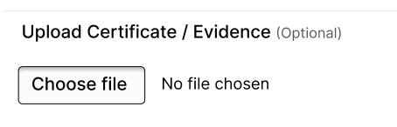
TC008 | Continue to view status | Skill submitted | Go to skill status page | Skill ID | Skill review status displayed | Status visible | Pass | Zubayer | 12-Mar-2026 | Zubayer | 12-Mar-2026 | 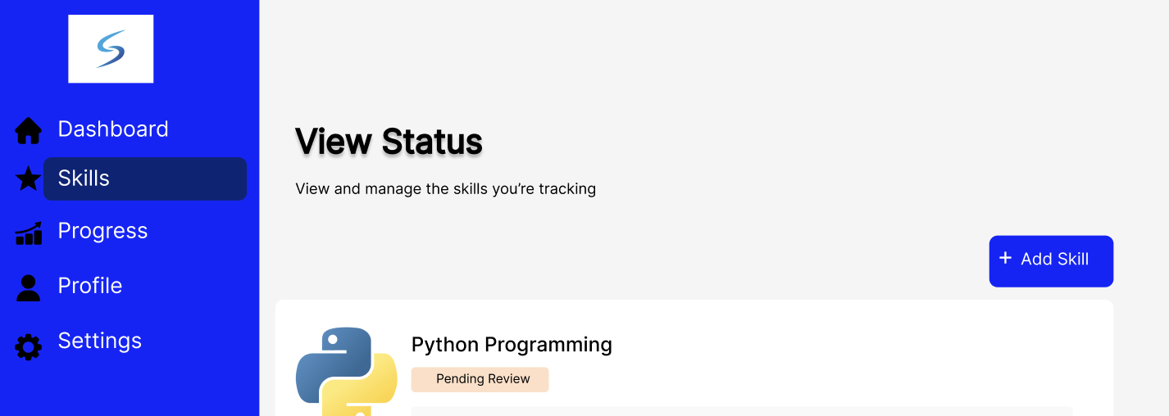
TC009 | Set new goal | Student logged in | Manage goals → Set goal | Goal name/category/date | Goal saved successfully | Goal added to list | Pass | Zubayer | 12-Mar-2026 | Zubayer | 12-Mar-2026 | 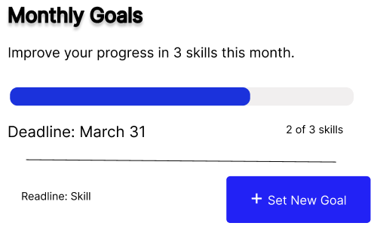
TC010 | Save goal | Goal details entered | Click Save | Goal details | Goal stored in system | Goal saved correctly | Pass | Zubayer | 12-Mar-2026 | Zubayer | 12-Mar-2026 | 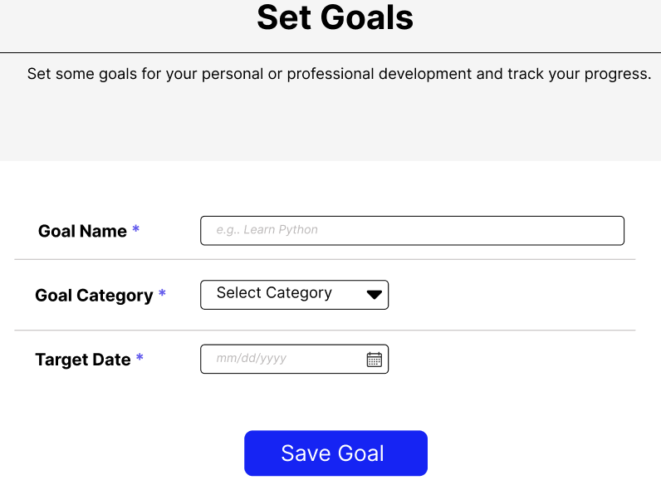
TC011 | View profile | Student logged in | Click profile | N/A | Profile displayed | Profile loads correctly | Pass | Zubayer | 12-Mar-2026 | Zubayer | 12-Mar-2026 | 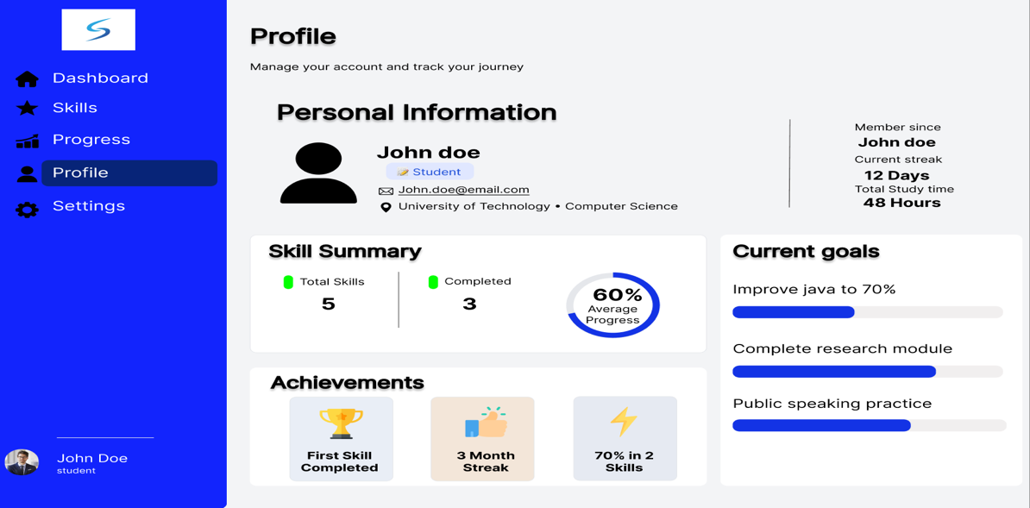
TC012 | Update account information | User logged in | Settings → Update info | Name/email | Info updated | Changes saved | Pass | Zubayer | 12-Mar-2026 | Zubayer | 12-Mar-2026 | 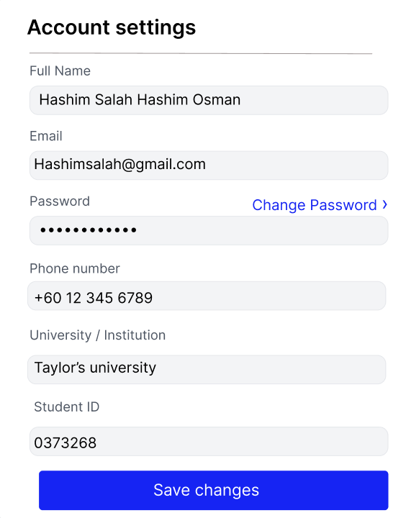
TC013 | Change password | User logged in | Settings → Change password | Password | Password changed OR error if incorrect | Password updated successfully | Pass | Zubayer | 12-Mar-2026 | Zubayer | 12-Mar-2026 | 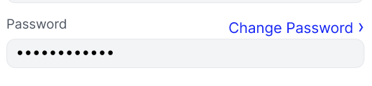
TC014 | Manage notification preferences | User logged in | Settings → Notifications | Notification options | Preferences saved | Settings updated | Pass | Zubayer | 12-Mar-2026 | Zubayer | 12-Mar-2026 | 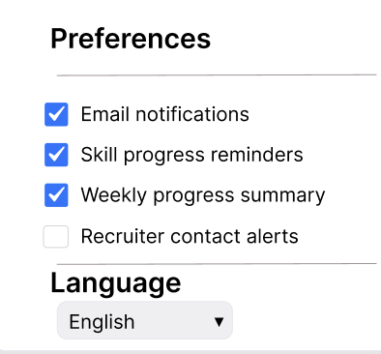
TC015 | Change theme | User logged in | Settings → Theme | Theme choice | Theme updated | Theme applied | Pass | Zubayer | 12-Mar-2026 | Zubayer | 12-Mar-2026 | 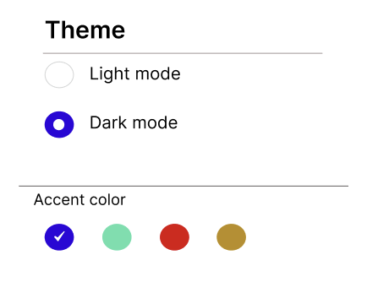
TC016 | Change accent color | User logged in | Settings → Accent color | Color option | Color updated | Accent color applied | Fail | Zubayer | 12-Mar-2026 | Zubayer | 12-Mar-2026 | 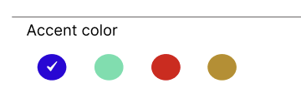
TC017 | Find students | Recruiter logged in | Navigate to Find students | N/A | List of students displayed | Students displayed correctly | Pass | Zubayer | 12-Mar-2026 | Zubayer | 12-Mar-2026 | 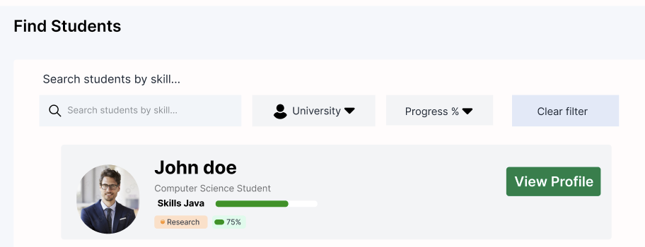
TC018 | Filter students by university | Recruiter logged in | Find students → Apply filter | University name | Filtered list displayed | Correct students shown | Pass | Zubayer | 12-Mar-2026 | Zubayer | 12-Mar-2026 | 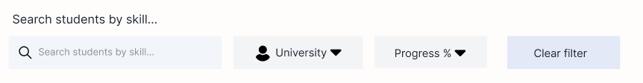
TC019 | Filter students by progress | Recruiter logged in | Apply progress filter | Progress % | Matching candidates displayed | Correct candidates listed | Pass | Zubayer | 12-Mar-2026 | Zubayer | 12-Mar-2026 | 
TC020 | Search for student | Recruiter logged in | Enter search query | Student name | Student profile found | Profile displayed | Pass | Zubayer | 12-Mar-2026 | Zubayer | 12-Mar-2026 | 
TC021 | View candidate profile | Recruiter logged in | Click candidate profile | Student ID | Candidate profile displayed | Profile visible | Pass | Zubayer | 12-Mar-2026 | Zubayer | 12-Mar-2026 | 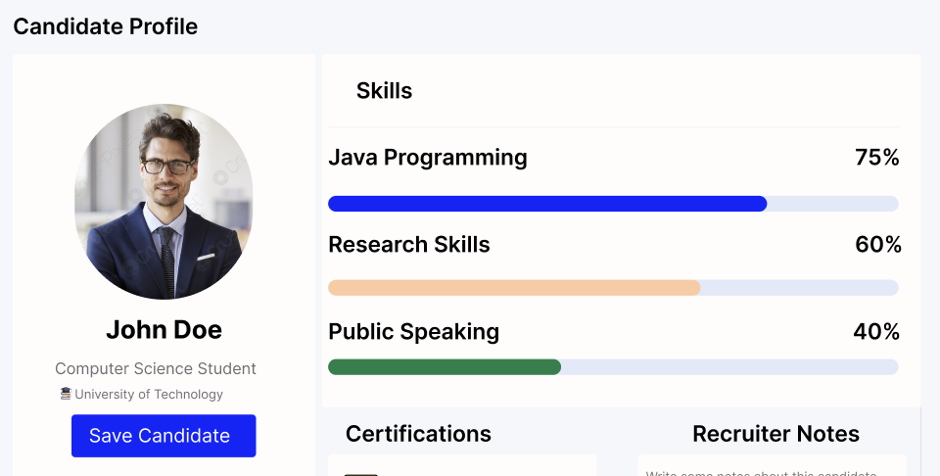
TC022 | Save candidate | Recruiter logged in | Click save candidate | Candidate ID | Candidate saved | Candidate stored in recruiter list | Pass | Zubayer | 12-Mar-2026 | Zubayer | 12-Mar-2026 | 
TC023 | Write note for candidate | Recruiter logged in | Open candidate → Write note | Note text | Note saved | Note appears in candidate profile | Pass | Zubayer | 12-Mar-2026 | Zubayer | 12-Mar-2026 | 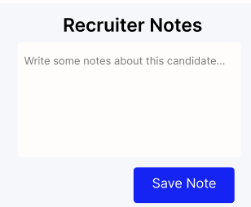
TC024 | User management (Admin) | Admin logged in | Open user management | N/A | User list displayed | Users visible | Pass | Zubayer | 12-Mar-2026 | Zubayer | 12-Mar-2026 | 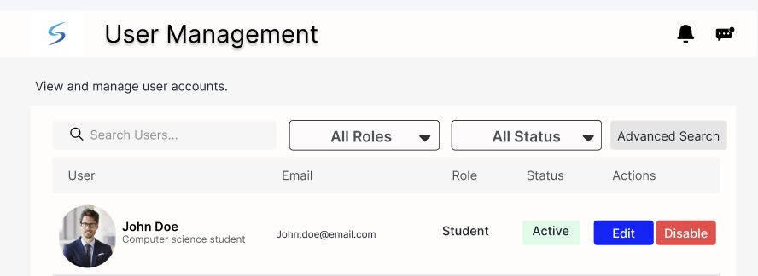
TC025 | Disable student account | Admin logged in | Select student → Disable | User ID | Account disabled | Student cannot log in | Fail | Zubayer | 12-Mar-2026 | Zubayer | 12-Mar-2026 | 
TC026 | Clear filter when searching students | Recruiter logged in | Open Find Students → Apply filters → Click Clear Filter | Filter parameters | All filters removed and full list of students shown | Filters cleared and full student list displayed | Pass | Zubayer | 12-Mar-2026 | Zubayer | 12-Mar-2026 | 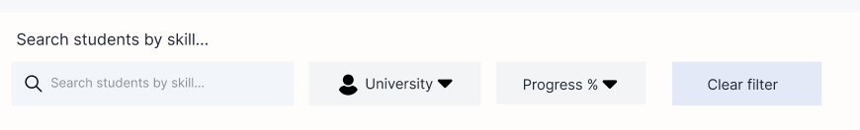
TC027 | View candidate progress | Recruiter logged in | Open Find Students → Select candidate → View progress | Candidate ID | Candidate progress displayed correctly | Progress details appear on screen | Pass | Zubayer | 12-Mar-2026 | Zubayer | 12-Mar-2026 | 
TC028 | View messages | Recruiter/Admin logged in | Click Messages section | N/A | Messages list displayed | Messages load successfully | Pass | Zubayer | 12-Mar-2026 | Zubayer | 12-Mar-2026 | 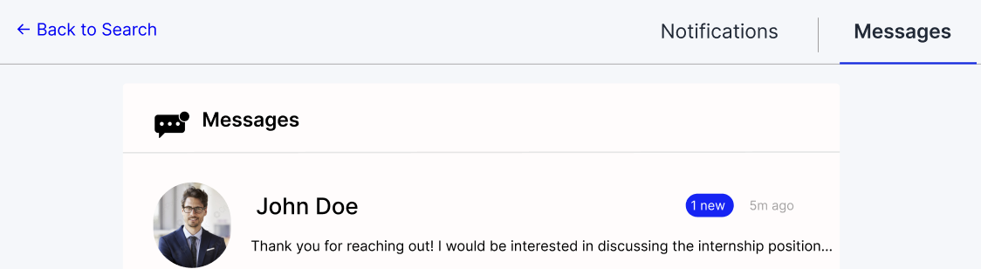
TC029 | View notifications | User logged in | Click notification icon | N/A | Notifications displayed | Notifications appear correctly | Pass | Zubayer | 12-Mar-2026 | Zubayer | 12-Mar-2026 | 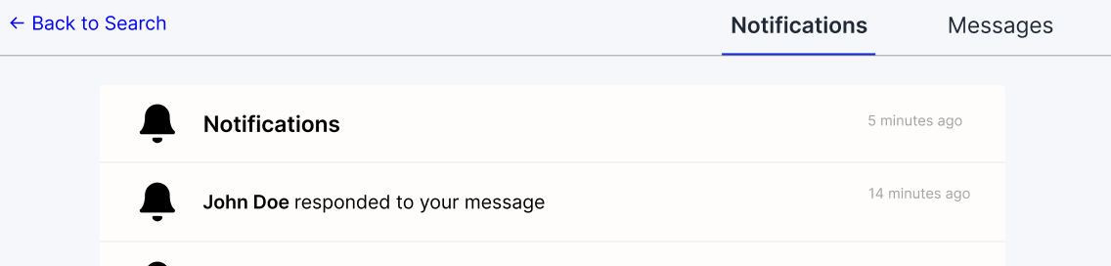
TC030 | Search user (Admin) | Admin logged in | Open User Management → Enter search query | Username / ID | System displays matching user | Correct user appears in result | Pass | Zubayer | 12-Mar-2026 | Zubayer | 12-Mar-2026 | 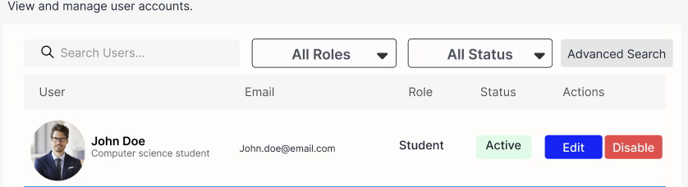
TC031 | Filter users by role | Admin logged in | User Management → Select role filter | Role type | Users filtered according to role | Correct users shown | Pass | Zubayer | 12-Mar-2026 | Zubayer | 12-Mar-2026 | 
TC032 | Filter users by status | Admin logged in | User Management → Apply status filter | Active/Inactive | System shows users according to status | Filter works correctly | Pass | Zubayer | 12-Mar-2026 | Zubayer | 12-Mar-2026 | 
TC033 | View advanced searches | Admin logged in | User Management → Open advanced search | Search parameters | Advanced search interface displayed | Advanced search works correctly | Pass | Zubayer | 12-Mar-2026 | Zubayer | 12-Mar-2026
TC034 | Certificate verification | Admin logged in | Open Certificate Verification → View certificate | Certificate ID | Certificate details displayed | Certificate displayed correctly | Pass | Zubayer | 12-Mar-2026 | Zubayer | 12-Mar-2026 | 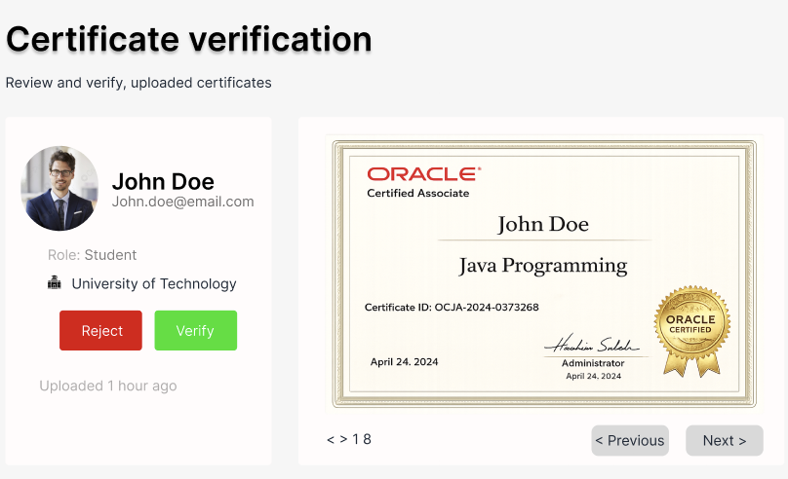
TC035 | Approve certificate | Admin logged in | Select certificate → Click Approve | Certificate ID | Certificate approved successfully | Certificate marked approved | Pass | Zubayer | 12-Mar-2026 | Zubayer | 12-Mar-2026 | 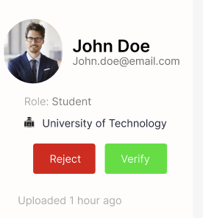
TC036 | Reject certificate | Admin logged in | Select certificate → Click Reject | Certificate ID | Certificate rejected successfully | Certificate marked rejected | Fail | Zubayer | 12-Mar-2026 | Zubayer | 12-Mar-2026 | 

